Group 7
Herrera, Mark Daniel L.
Panaligan, Judy A.
Macalindong, Anne Francine
Lorenzo, Maui
Ponce, Kris Jolo

Materials | Description | Quantity | Price | Subtotal | Screenshot
Coin Acceptor | Used to detect and validate coins for payment | 1 | 499 | 499 | 
Servo Motor 35Kg | Used for opening and closing the dispensing gate | 1 | 566 | 566 | 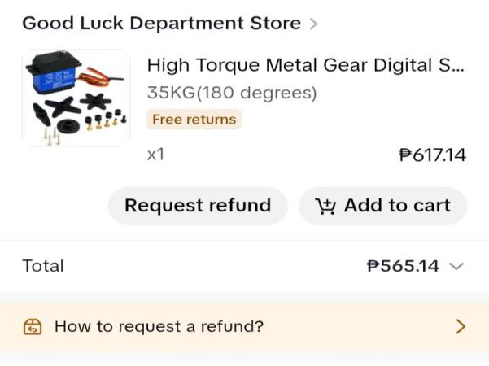
Button | Used to manually start or control the dispensing process in the machine. | 4 | 20 | 90 | 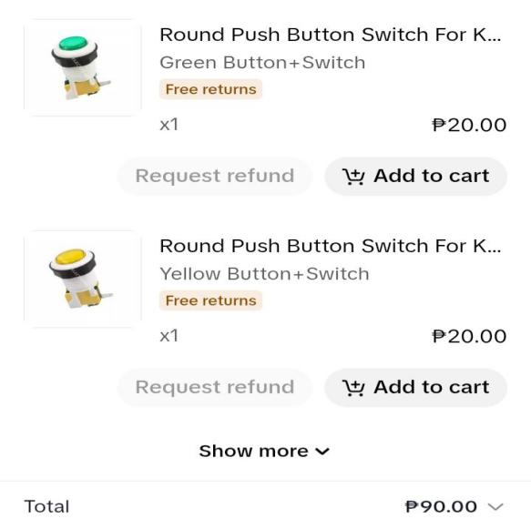
Plywood | Used for building the main structure or body frame of the rice vendo machine. | 1 | 350 | 350
dospordos | Used for the foundation/frame support of the rice vendo machine to make the structure strong and stable. | 1 | 300 | 300
Kahoy | Used for the internal frame support where the plywood is attached, providing structure and height without directly bearing the outer load. | 2 | 200 | 400
Nail | Used for fastening and securing the wooden parts of the frame to make the structure strong and stable. | 1/4 | 25 | 25
Power Supply | Used to provide stable electrical power for all components of the rice vendo machine, such as the servo, ESP32, and other modules. | 1 | 199 | 189 | 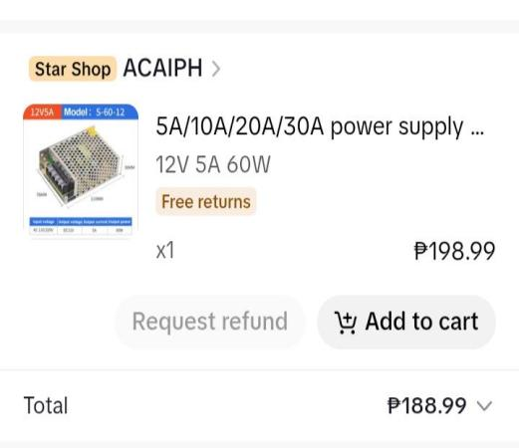
Elctrical  Tape | Use to secure all open wire, to make sure the safety | 1 | 14 | 14 | 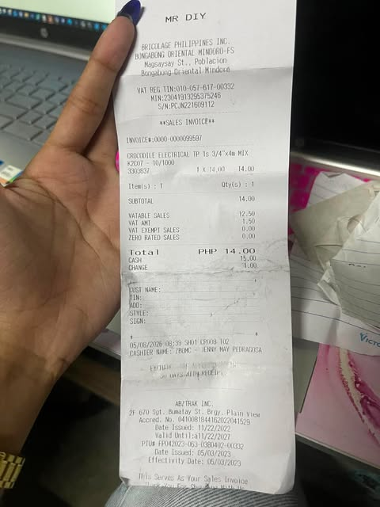
Shinges | are durable metal hinges commonly used for doors, cabinets, and wooden projects to allow smooth opening and closing movement. | 2 | 50 | 100 | 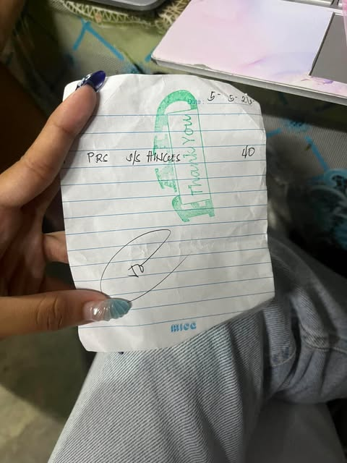
Hat cord | an insulated electrical cord commonly used for light-duty wiring connections in appliances, lamps, or small electrical devices. | 3 | 15 | 45 | 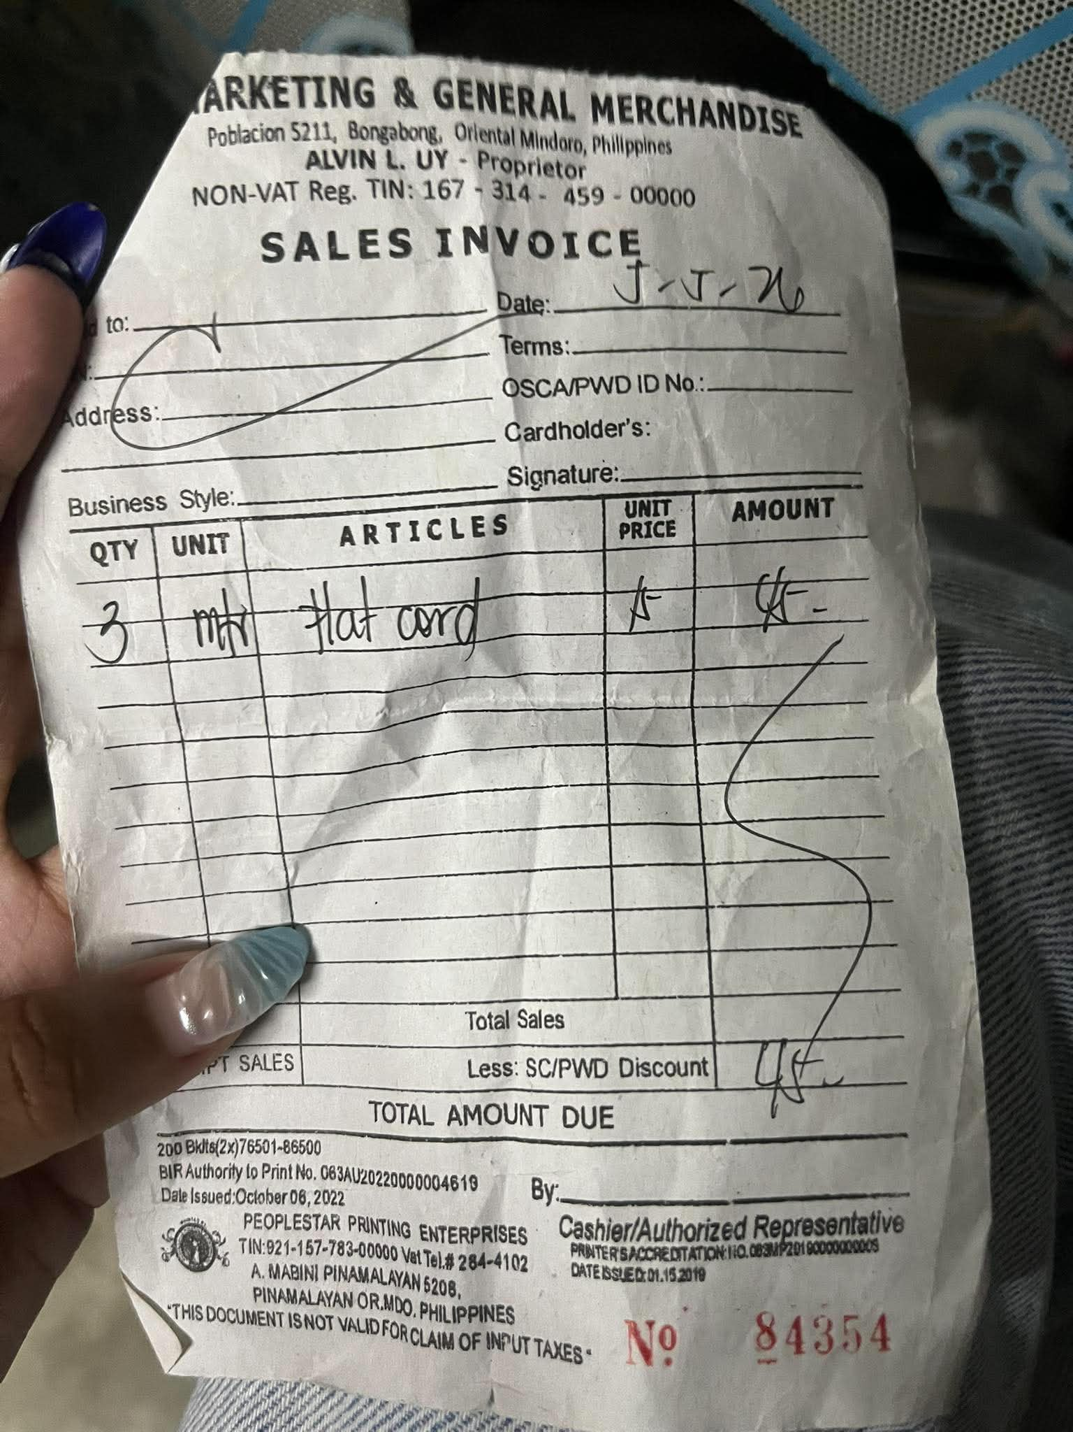
Wire # 18 | Wire #18 (18 AWG) is a medium-sized electrical wire commonly used for low-current circuits, small appliances, lighting, and electronics | 2 | 35 | 70 | 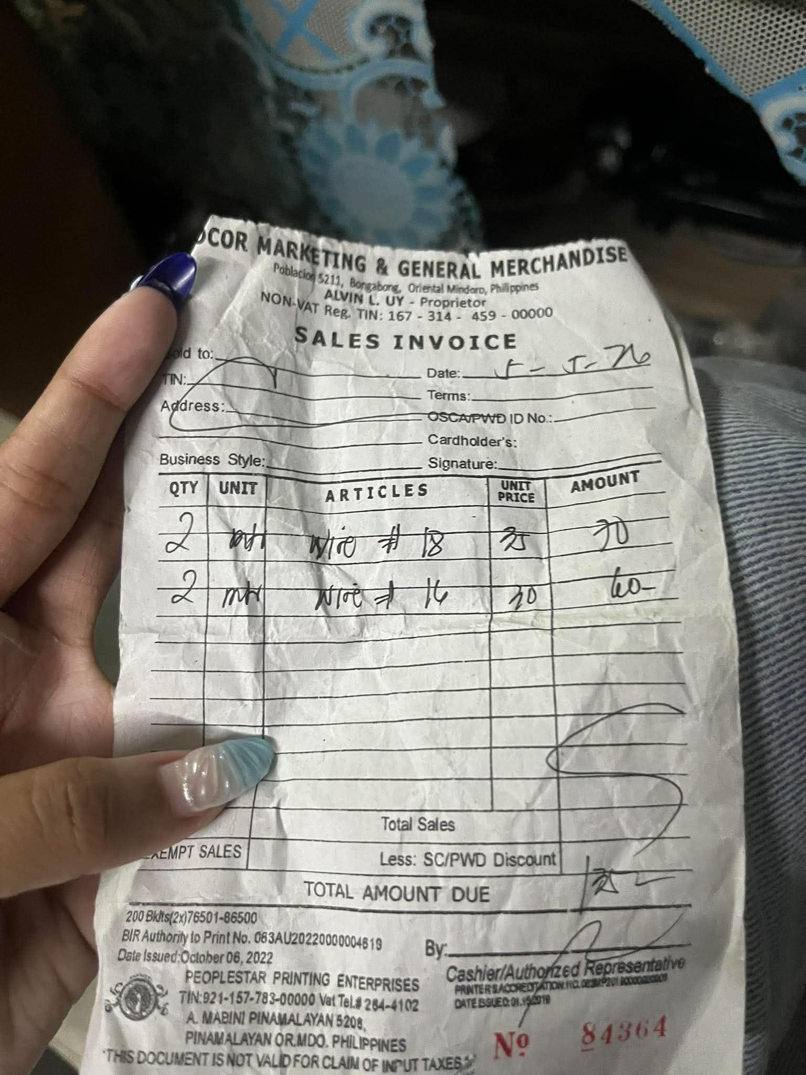
Wire # 16 | is a thicker electrical wire than #18 and is used for circuits that require higher current capacity, such as extension cords and power connections. | 2 | 30 | 60 | 
Lock | a security device used to secure doors, cabinets, gates, or boxes to prevent unauthorized access | 2 | 25 | 50 | 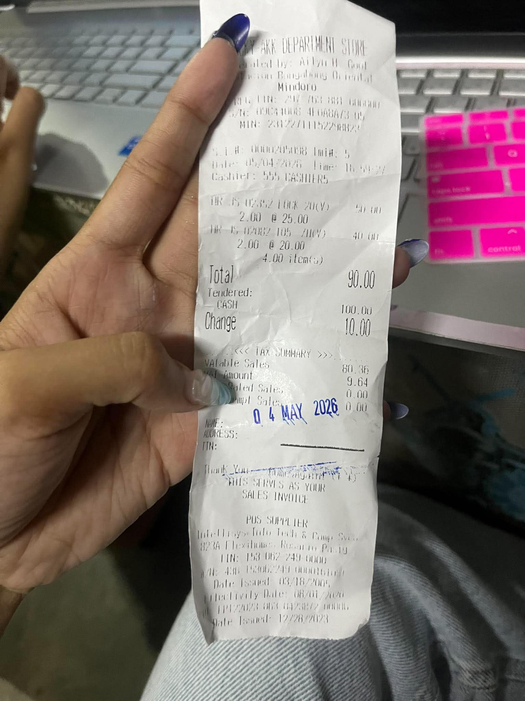
Hasp | a metal fastening device with a hinged plate and staple used together with a padlock to secure doors, cabinets, or storage boxes. | 2 | 20 | 40 | 
Handle out | A handle-out is a type of door or cabinet handle installed on the outside part for pulling or opening doors, panels, or enclosures. | 2 | 50 | 100 | 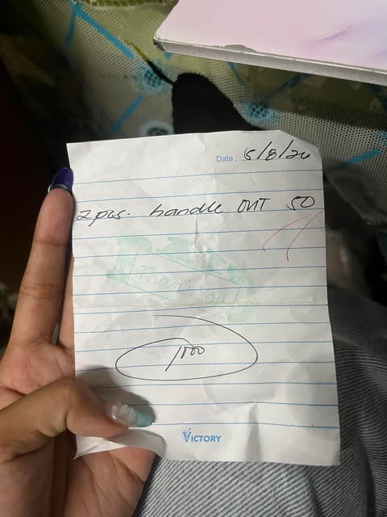
Total |  |  |  | 2,898

Materials | Description | Quantity | Price | Subtotal | Screenshot
Servo Motor |  | 1 | 88 | 113 | 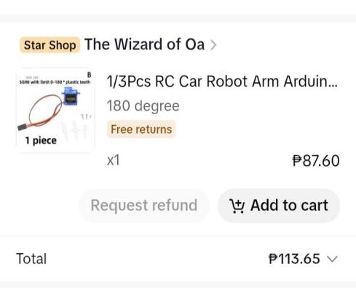
Servo Motor |  | 3 | 68 | 230 | 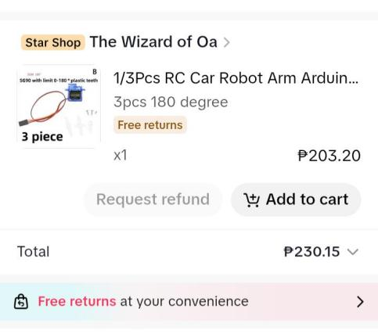
Total |  |  |  | 343

